If you have are running Macintosh OS X 10.6 or a 64-bit version of Linux you have the option of installing GemStone as a native application on your machine. This approach is a bit more complex to get right, but allows you to run GemStone without the virtual machine overhead. The following script shows how to do the install (see <http://seaside.gemstone.com/downloads.html> for details):

mkdir /opt/gemstone \

/opt/gemstone/backups /opt/gemstone/locks /opt/gemstone/log

cd /opt/gemstone

curl http://seaside.gemstone.com/jade/GemStone64Bit2.4.4.4-i386.Darwin.zip \

>GemStone64Bit2.4.4.4-i386.Darwin.zip

curl http://seaside.gemstone.com/scripts/installGemstone.sh \

>installGemstone.bak

sed s/2.4.4.1/2.4.4.4/ <installGemstone.bak | \

sed s/x86_64.MacOSX/i386.Darwin/ >installGemstone.sh

chmod 700 installGemstone.sh

./installGemstone.sh

This script will prompt you for your password so it can update kernel memory settings (feel free to study the script if you have any concerns). After the script completes, continue with the following to start GemStone (you can use this script later to start GemStone again):

source /opt/gemstone/product/seaside/defSeaside

startnet

startGemstone

gslist -cvl

If things are working properly, you should see three processes running. Now to login using a GUI we need to download GemTools, a Pharo-based GUI for GemStone/S.

curl http://seaside.gemstone.com/squeak/GemTools-1.0-beta.8-244x.app.zip > \

GemTools.zip

unzip GemTools.zip

open GemTools-1.0-beta.8-244x.app/

This should open GemTools with a single window, the GemTools Launcher:

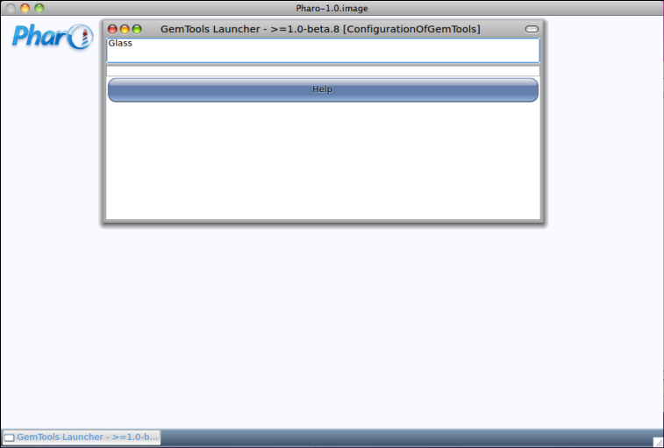

Click on the 'Glass' entry in the list area in the top section of the Launcher. This will change the single 'Help' button into a row of five buttons.

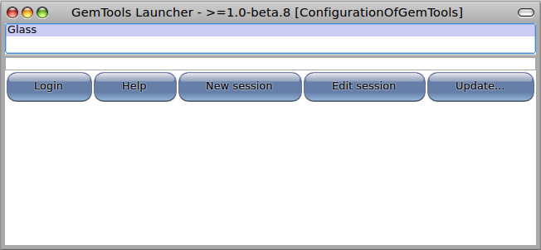

Click on the 'Update…' button and then select 'Update GemTools Launcher' from the update menu. As this is working it will show some progress dialogs. When it is done it will inform you what version is loaded.

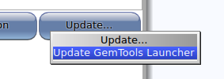 Screen shot 2011-02-13 at 2.53.30 PM.png 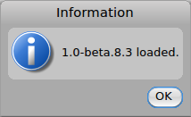

Repeat the above process and select the top line (here, 1.0-beta.8.4). This will open a Pharo Help window (you may close it), and inform you that version 1.0-beta.8.4 is loaded. Continue to repeat the process until the top line has a * next to it (indicating that the most recent 'released' version is loaded). At this point you may click 'Cancel' since we do not need to update the client (we will update the server soon).

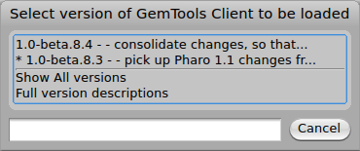 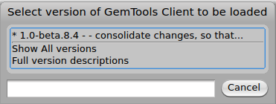

After the update process we will create the login parameters for a new session. Click the 'New Session' button in the center of the five buttons and select 'Standard' from the list of types. Edit the template to change the name to 'Seaside', replace the stoneHost and the gemHost with 'localhost', and set the backup directory to '/opt/gemstone/backups'. When you have made the edits click 'OK'.

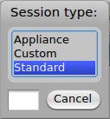 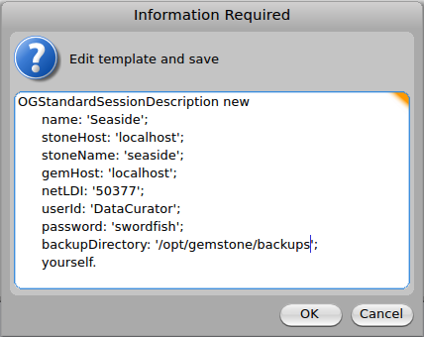

This will add a new 'Seaside' line to the list of defined session types in the Launcher. Select the new session type by clicking on the 'Seaside' line and then click on the 'Login' button. This should present you with a dialog asking for your name. Enter your name without spaces and without punctuation characters, and click 'OK'. A successful login should result in a change in the buttons to include a set starting with 'Logout' and ending with 'Update'.

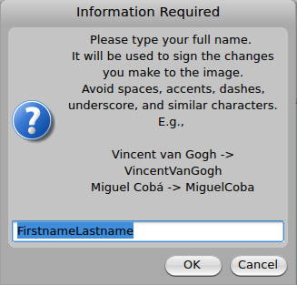 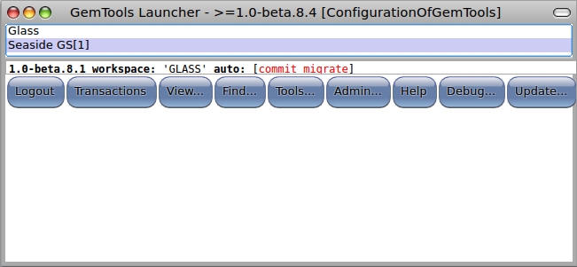

Note that after the login, there is an info line that tells us that we have 1.0-beta.8.1 loaded into the server (GemStone/S), we have a workspace named 'GLASS', and GemTools is configured for auto-commit and auto-migrate. Auto-commit means that each server-related action in GemTools will be followed by a commit. This is the default mode and ensures that you do not lose any work. The auto-migrate mode means that when you change the schema for a class (typically by adding an instance variable), GemTools will scan the database for all instances of that class and migrate the instances to the new schema. This setting provides behavior comparable to what you experience with other Smalltalks but is associated with non-trivial overhead in GemStone since the object space is disk-based rather than RAM based and can be quite large.

Click on the 'Update' button and select 'Update GLASS'. Select 1.0-beta.8.5 (even though it has an asterisk by it implying that it is already loaded—it is not loaded, this is a bug in beta.8.1). When the update finishes, note that the info line shows 1.0-beta.8.5 as the current version.

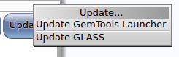 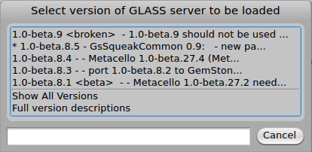

At this point, click the 'Logout' button to disconnect from the database server. Since we have added a session type and updated the client, we want to save the Pharo image. Click on the desktop and from the World menu select 'Save'.

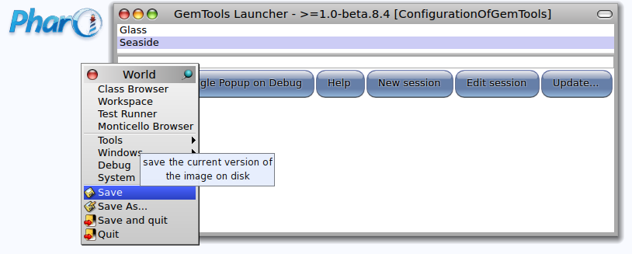

Unlike the Seaside One-Click Experience, GemStone does not have Seaside pre-loaded. This is because you might want to load only part of Seaside. In our case, we will go ahead and load everything. Following the instructions at <http://code.google.com/p/glassdb/wiki/Seaside30Configuration>, start by logging in (click the Login button) and enter the following text into the workspace (the text area below the buttons):

MCPlatformSupport commitOnAlmostOutOfMemoryDuring: [

Gofer project load: 'Seaside30' version: '3.0.3'.

].

Select all the text (<Ctrl>+<S>), and then right-click to get a context menu and select 'do it (d)' from the menu (or use <Ctrl>+<D>). The cursor will change to something like a GemStone/S logo (six triangles in a triangle) and will run for some time (several minutes).

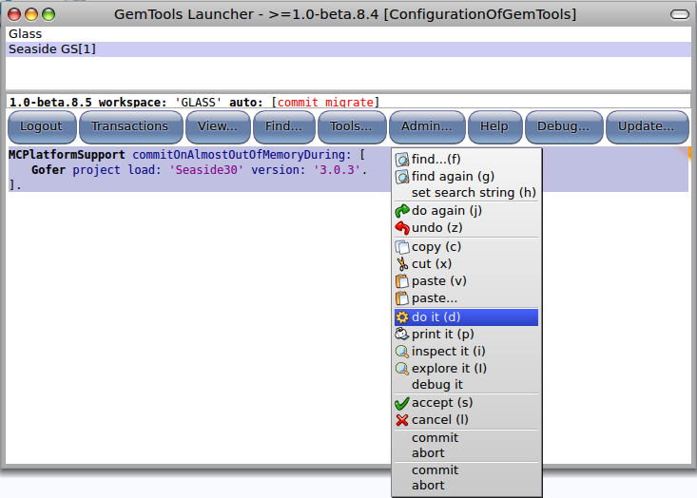

Now we will start a web server. Evaluate the following expression in the workspace:

WAGemStoneRunSeasideGems default adaptorClass: WAGsSwazooAdaptor.

This informs GemStone that you want to run a web server in GemStone. Before starting the web server, open a Pharo Transcript by clicking on the Pharo desktop to get the World menu, select 'Tools' then 'Transcript'. Then, from the Launcher window, click on the 'Admin…' button to get the Admin menu. Select 'Seaside gems' and 'Start'. The Transcript should show that four gems have been started, three WAGsSwazooAdaptor gems (on ports 9001 to 9003) and one maintenance gem.

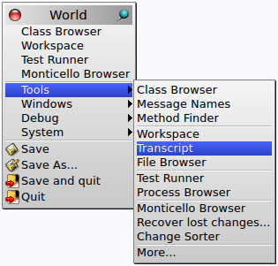 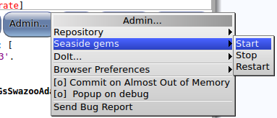

Open a web browser on <http://localhost:9001/> and you should see the Seaside welcome page.

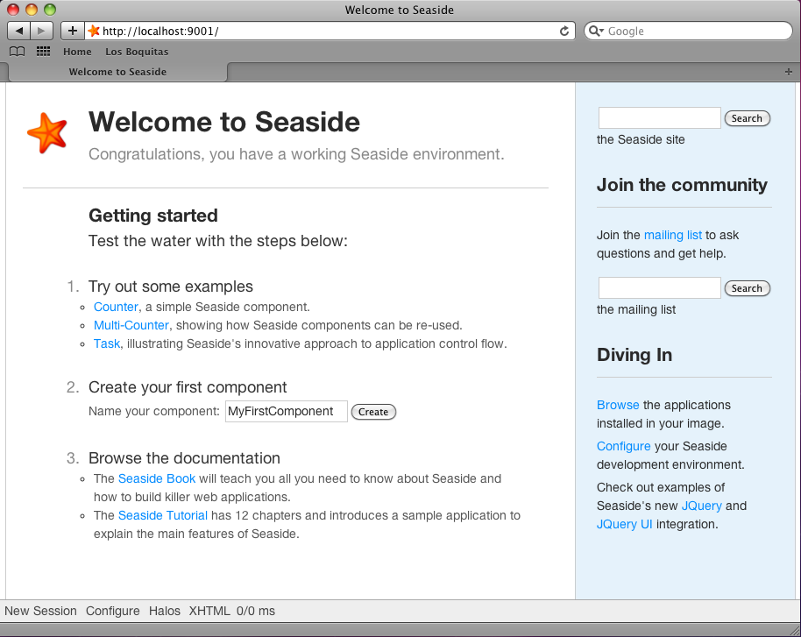

This web page is being served by Swazoo, a Smalltalk web server in GemStone, but it is not the same virtual machine that is handling your GemTools window. It is another OS process. To get an idea of what is running on your system, enter the following command in a Terminal:

ps –ef | grep gemston[e] | cut -c-120

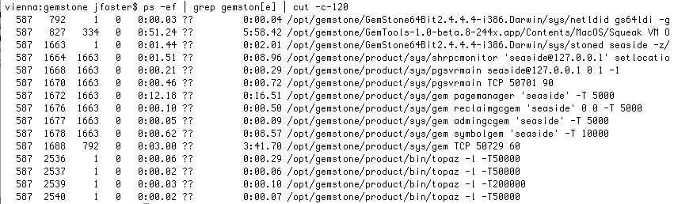

The first process, netldid (PID 792), is available to start gems for GemTools. The second process, Squeak (PID 827), is the VM that is running GemTools. The next process, stoned (PID 1663), is the primary database process and the following seven processes are started by the stone to handle various tasks (you can see that the third column, parent PID, is the stone). Next is a gem (PID 1688) started by the NetLDI (so the parent PID is 792). The remaining four processes are topaz and were started when you selected 'Start' from the 'Seaside gems' menu from the Admin menu.

Now we will explore using FastCGI with Apache as the web server. In a Terminal, create some directories and a new Apache config file. The Apache config file will be placed in a protected directory, so you will be prompted for an administrative password.

mkdir /opt/gemstone/apache /opt/gemstone/apache/logs \

/opt/gemstone/apache/htdocs \

/opt/gemstone/apache/htdocs/seaside1 \

/opt/gemstone/apache/htdocs/seaside2 \

/opt/gemstone/apache/htdocs/seaside3

echo '# Apache config file for Seaside using FastCGI in GemStone

<VirtualHost *:80>

ProxyPreserveHost On #make proxy rewrite urls in the output

ProxyPass /favicon.ico !

ProxyPass /css !

ProxyPass /images !

ProxyPass /scripts !

ProxyPass / balancer://gemtrio/

ProxyPassReverse / balancer://gemtrio/

<Location /balancer-manager>

SetHandler balancer-manager

Order deny,allow

Deny from all

Allow from localhost

</Location>

</VirtualHost>

<Proxy balancer://gemtrio>

BalancerMember http://localhost:8081

BalancerMember http://localhost:8082

BalancerMember http://localhost:8083

</Proxy>

Listen 8081

<VirtualHost *:8081>

CustomLog /opt/gemstone/apache/logs/seaside-vhost-8081-access.log combined

ErrorLog /opt/gemstone/apache/logs/seaside-vhost-8081-error.log

LogLevel warn

DocumentRoot /opt/gemstone/apache/htdocs/seaside1/

<Location "/">

Order deny,allow

Deny from all

Allow from localhost

</Location>

</VirtualHost>

Listen 8082

<VirtualHost *:8082>

CustomLog /opt/gemstone/apache/logs/seaside-vhost-8082-access.log combined

ErrorLog /opt/gemstone/apache/logs/seaside-vhost-8082-error.log

LogLevel warn

DocumentRoot /opt/gemstone/apache/htdocs/seaside2/

<Location "/">

Order deny,allow

Deny from all

Allow from localhost

</Location>

</VirtualHost>

Listen 8083

<VirtualHost *:8083>

CustomLog /opt/gemstone/apache/logs/seaside-vhost-8083-access.log combined

ErrorLog /opt/gemstone/apache/logs/seaside-vhost-8083-error.log

LogLevel warn

DocumentRoot /opt/gemstone/apache/htdocs/seaside3/

<Location "/">

Order deny,allow

Deny from all

Allow from localhost

</Location>

</VirtualHost>

LoadModule fastcgi_module libexec/apache2/mod_fastcgi.so

FastCgiExternalServer /opt/gemstone/apache/htdocs/seaside1 \

-host localhost:9001 -pass-header Authorization

FastCgiExternalServer /opt/gemstone/apache/htdocs/seaside2 \

-host localhost:9002 -pass-header Authorization

FastCgiExternalServer /opt/gemstone/apache/htdocs/seaside3 \

-host localhost:9003 -pass-header Authorization

' | sudo tee /etc/apache2/other/seaside.conf

At this point we need to restart so it can pick up the new configurations. Ideally, we should be able to do this from Terminal using the following:

sudo apachectl restart

If this does not complain, then you should be fine. If you get an invalid argument error ('/usr/sbin/apachectl: line 82: ulimit: open files: cannot modify limit: Invalid argument') then see <http://www.456bereastreet.com/archive/201011/mac_os_x_1065_broke_my_apachectl/>. As an alternative, open System Preferences, select Sharing, and then uncheck and then check the 'Web Sharing' checkbox. This will stop and start Apache.

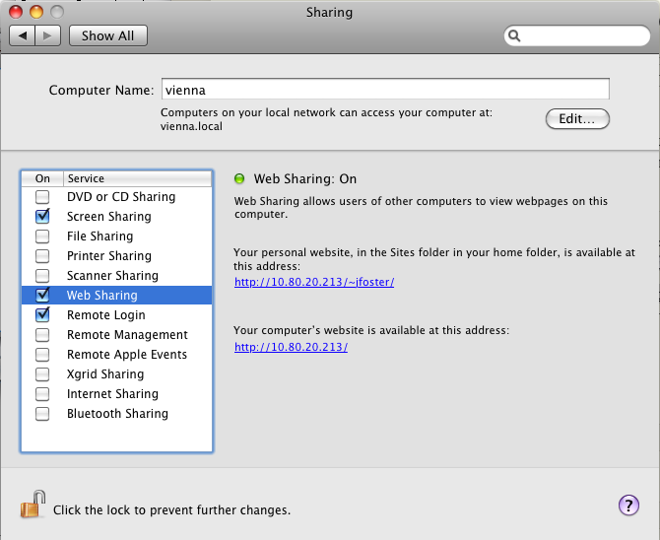

In your GemTools workspace, set Seaside to use FastCGI (<Ctrl>+<D>):

WAGemStoneRunSeasideGems default adaptorClass: WAFastCGIAdaptor.

Now, from the Admin menu, select 'Seaside gems' and 'Start'. You should be able to go to a web browser and navigate to <http://localhost/>. Note that we did not need to provide a port (such as 8080 or 9001), because we are now using the web server provided as part of the Mac OS. This allows you to use Apache to serve static files (images, CSS, JavaScript, etc.), while using Seaside to serve the dynamic content. You can edit the config file to exclude other local directories.

Now would be a good time to do a backup. From the Launcher, click the 'Admin…' button, select 'Repository' and then 'Backup'. You can name your backup (or accept the default), and then click OK.

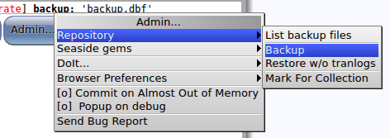

When you are done, stop the Seaside gems (from the Admin menu) and click the 'Logout' button. Then in a terminal you can stop GemStone with the following line:

source /opt/gemstone/product/seaside/defSeaside; stopGemstone; stopnetldi

You can learn more about GemTools at <http://code.google.com/p/glassdb/wiki/GemTools>.